**INDUSTRYINTERNSHIP PROJECT (IIP)**

A Project Report On

**“A STUDY ON ANALYSIS AND FORECASTING OF GLOBAL SMART GREENHOUSE MARKET”**

With special reference to

**Prudour Pvt. Ltd. (Pune)**

In partial fulfillment of the requirement for the award of

**MASTER OF BUSINESS ADMINISTRATION**

Submitted by,

**Mr. Akash Sadanand Nikam**

(Roll No. – 2140049, MBA – II, Div. - A)

Under the guidance of

**Dr. Krishnaji S. Patil**

(M. Com, MBA, UGC-NET)

Through



The Director

Rajarambapu Institute of Technology, Rajaramnagar

Academic Year

2022 – 2023

**RAJARAMBAPU INSTITUTE OF TECHNOLOGY, RAJARAMNAGAR**

(An Autonomous Institute affiliated with Shivaji University, Kolhapur) Rajaramnagar (Sakhrale), Islampur, Dist.- Sangli

**CERTIFICATE**

This is to certify that the project work is entitled.

**“A STUDY ON ANALYSIS AND FORECASTING OF GLOBAL SMART GREENHOUSE MARKET”**

With special reference to

**Prudour Pvt. Ltd. (Pune)**

In partial fulfillment of the requirement for the award of

**MASTER OF BUSINESS ADMINISTRATION (M. B. A.)**

Submitted by,

**Mr. Akash Sadanand Nikam**

(Enrolment No. 2140049)

Under the guidance of

**Dr. Krishnaji S. Patil**

This project is submitted through the Director, Rajarambapu Institute of Technology, Rajaramnagar, during the academic year 2022 - 2023.

Date:

**Head Director**

**Dept. of Mgt. Studies (MBA) RIT, Rajaramnagar**

**Company Certificate**

**GUIDE CERTIFICATE**

This is to certify that the internship under Industry Internship & Project (IIP) was completed at Prudour Pvt. Ltd. It is the bonafide work submitted by the following student, to the Rajarambapu Institute of Technology, Rajaramnagar, during the academic year 2022-2023, in partial fulfillment for the award of the degree of Master in Business Administration under our supervision; this project is carried out under my guidance & supervision. To the best of my knowledge and belief, the contents of this report, in whole or in parts, have not been submitted to any other Institution or University for the award of any degree.

|  |  |
| --- | --- |
| Name of Student | Roll No. |
| Mr. Akash Sadanand Nikam | 2140049 |

Date:

Place: RIT, Rajaramnagar

**Dr. Krishnaji S. Patil**

**IIP Mentor**

**DECLARATION**

This report reflects my thoughts about the subject in my own words. I have sufficiently cited and referenced the sources referred to o considered in this work. I have submitted different results for the position than any of my other degrees. I also declare that; I have followed all principles of academic honesty and integrity and have not misrepresented, fabricated, or falsified any idea, data, fact, or source in my submission. I understand that any violation of the above will be cause for disciplinary action by the Institute.

|  |  |  |
| --- | --- | --- |
| Student Name | Roll No. | Signature |
| Mr. Akash Sadanand Nikam | 2140049 |  |

Date:

Place: RIT, Rajaramnagar

**ACKNOWLEDGEMENT**

I take this opportunity to thank all those who have contributed to completing an Internship under the Industry Internship Program (IIP) at “Prudour Pvt. Ltd.” I sincerely wish to express my gratitude to my Industry Internship Program Mentor Dr. Krishnaji Patil sir, for his full support, expert guidance, encouragement, and kind cooperation throughout the Internship work. I am greatly indebted to her for her help throughout the project work. I sincerely thank Dr. Hemlata Gaikwad, HOD, Management Studies, for providing the necessary facilities, guidance, and support.

I respect and thank Prudour Pvt. Ltd. for providing me with an opportunity to do a project and giving us all support and guidance, which made me complete the internship project. Thankful to him and his all-staff members, especially Mr. Anurag Sharma sir and Mrs. Swapnali Parchande Mam, for providing me with good support and guidance.

I thank Mr. Madhav U. Tilwe sir (Dept. TPO) & (IIP Faculty Coordinator) for providing an internship & Project Opportunity.

I am thankful for and fortunate enough to get constant encouragement, support, and guidance from all the Management Studies Department Teaching staff, which helped me complete an internship.

Lastly, I express my gratitude to my family members for their kind cooperation and encouragement, which helped me to complete this internship.

**Mr. Akash Sadanand Nikam**

**MBA-II,**

**Roll No. – 2140049**

**Executive Summary**

This research topic concerns “A Study on Analysis and Forecasting of Global Smart Greenhouse Market” with special reference to Prudour Pvt. Ltd.

The global Smart Greenhouse market has witnessed significant growth in recent years, Smart greenhouses have emerged as a solution to optimize crop production, improve resource efficiency, and ensure sustainable farming practices. These technologically advanced systems integrate a range of cutting-edge technologies such as sensors, automation, artificial intelligence, and data analytics. By leveraging real-time data from sensors, smart greenhouses can precisely monitor and control environmental factors such as temperature, humidity, light levels, and CO2 concentration. This enables farmers to create an ideal growth environment for plants, maximizing yield and quality while minimizing resource waste. Automated irrigation systems ensure efficient water usage, while precise nutrient management techniques like hydroponics promote optimal plant nutrition.

Table of Content

Chapter No. – I INTRODUCTION OF THE STUDY 13

1.1 Introduction: 13

1.2 Research Problem: 14

1.3 Statement of the Problem: 14

1.4 Objectives of the Study: 14

1.5 Importance and Significance of the Study: 14

1.6 Scope of the Study: 15

1.7 Research Methodology: 15

1.8 Limitation of the Study: 16

1.9 Chapterization: 17

Chapter – II LITERATURE REVIEW 18

2.1 Introduction: 19

2.2 Literature Review: 22

Chapter – III Organization Profile 23

3.1 Name of the Company: 24

3.2 Overview: 24

3.3 Company Profile: 25

Chapter – IV Conceptual Framework 34

4.1 Introduction: 35

4.2 Drivers for the Smart Greenhouse Market 35

4.3 Restraints for the Smart Greenhouse Market 36

4.4 Opportunities for Smart Greenhouse Market 36

4.5 Trends in the Smart Greenhouse Market 37

4.6 COVID-19 Impact on the Smart Greenhouse Market 37

4.7 Dominating Region of the Smart Greenhouse Market 38

4.8 Market Overview: 38

4.9 Conclusion: 42

Chapter – V Data Analysis and Interpretation 43

5.1 Introduction: 44

5.2 Data Analysis and Interpretation: 45

Chapter – VI Findings, Conclusion, and Suggestions 56

6.1 Introduction: 57

6.2 Findings 57

6.3 Suggestions: 58

6.4 Conclusion: 59

REFERENCES / BIBLIOGRAPHY 61

Bibliography

List of Figures

Fig. 1 Market Growth of Global Smart Greenhouse Market From 2022 to 2032:

Fig. 2 Global Smart Greenhouse Market Share Comparison by Type (2016-2032)

Fig. 3 Global Smart Greenhouse Market Share Comparison by End-User (2016-2032)

Fig. 4 Global Smart Greenhouse Market Share Comparison by Component (2016-2032)

Fig. 5 Global Smart Greenhouse Market Share Comparison by Growth Opportunities (2022)

Fig. 6 Global Smart Greenhouse Pre Covid-19 Market Share Comparison (2022)

Fig. 7 Global Smart Greenhouse Post Covid-19 Market Share Comparison (2022)

Fig. 8 Global Smart Greenhouse Market Share Comparison by Region (2022)

List of Tables

Table 1 Market Growth of Global Smart Greenhouse Market From 2022 to 2032:

Table 2 Global Smart Greenhouse Market Share Comparison by Type (2016-2032)

Table 3 Global Smart Greenhouse Market Share Comparison by End-User (2016-2032)

Table 4 Global Smart Greenhouse Market Share Comparison by Component (2016-2032)

Table 5 Global Smart Greenhouse Market Share Comparison by Growth Opportunities (2022)

Table 6 Global Smart Greenhouse Pre Covid-19 Market Share Comparison (2022)

Table 7 Global Smart Greenhouse Post Covid-19 Market Share Comparison (2022)

Table 8 Global Smart Greenhouse Market Share Comparison by Region (2022)

Chapter No. – I INTRODUCTION OF THE STUDY

**1.1 Introduction**

**1.2 Research Problem**

**1.3 Statement of the Problem**

**1.4 Objectives of the Study**

**1.5 Hypothesis of the Study**

**1.6 Importance and Significance of the Study**

**1.7 Scope of the Study**

**1.8 Research Methodology**

**1.9 Limitations of the Study**

**1.10 Chapterization**

**Chapter - I**

## **1.1 Introduction:**

Smart greenhouses have emerged as a solution to optimize crop production, improve resource efficiency, and ensure sustainable farming practices. These technologically advanced systems integrate a range of cutting-edge technologies such as sensors, automation, artificial intelligence, and data analytics. By leveraging real-time data from sensors, smart greenhouses can precisely monitor and control environmental factors such as temperature, humidity, light levels, and CO2 concentration. This enables farmers to create an ideal growth environment for plants, maximizing yield and quality while minimizing resource waste. Automated irrigation systems ensure efficient water usage, while precise nutrient management techniques like hydroponics promote optimal plant nutrition.

The remote monitoring and control capabilities of smart greenhouses empower farmers to access and manage greenhouse conditions from anywhere. They can make timely adjustments, respond to alerts, and optimize operations for improved productivity and reduced operational costs. Additionally, advanced data analytics enable predictive insights, empowering farmers to anticipate and mitigate potential issues before they affect crop health or yield. The global smart greenhouse market is being driven by various factors, including the increasing demand for food production due to population growth, the need for sustainable farming practices, and the rising adoption of precision agriculture technologies. Furthermore, government initiatives promoting sustainable agriculture and the growing awareness about climate change's impact on food security are further fueling the market's growth.

## **1.2 Research Problem:**

I am trying to analyze and forecast the next 10 years growth of the “Smart Greenhouse” market globally. It will help the organization to provide reliable feedback to their clients.

## **1.3 Statement of the Problem:**

A Study on Analysis and Forecasting of Global Smart Greenhouse Market.

## **1.4 Objectives of the Study:**

1. To study the future growth of the Global Smart Greenhouse market.

2. To study the various segments of Smart Greenhouse.

3. To analyze the market opportunities and growth factors.

3. To analyze the COVID-19 impact on the Smart Greenhouse market.

## **1.5 Importance and Significance of the Study:**

**1.5.1 Importance to Researcher:**

1. The study provides a comprehensive understanding of the current market dynamics, trends, and future prospects of the global Smart Greenhouse industry.
2. The study enhances consumer awareness and understanding of Smart Greenhouse.
3. Researcher get to know about future growth of the market.
4. Researcher can forecast the trend of the market with the help of this research.

**1.5.2 Importance to the Organization:**

1. This study will help a drug organization to do strategic planning and gain competitive advantage.
2. This study also help an organization to make strategic decisions.

## **1.6 Scope of the Study:**

For this research project, the scope is global market. The company wants to know about future trend of the market. The data is collected from the past information and past values and compound annual growth rate (CAGR) for following purpose:

1. Study covers the trend of the market.
2. Study covers future growth of the market.

## **1.7 Research Methodology:**

**1.7.1 Type of Research:**

For this study, I applied a ‘Descriptive research design’; This design aims to describe and summarize the characteristics, patterns, and relationships within the secondary data. It involves collecting data from existing sources and analyzing it to provide a comprehensive overview of a particular topic or phenomenon. Descriptive research designs often use quantitative methods, such as statistical analysis, to present numerical summaries, charts, and graphs.

**1.7.2 Data Required:**

For this study I am using secondary data for future forecasting. For this study I have collected the data like current market value and compound annual growth rate (CAGR).

**1.7.3 Data Sources:**

The sources of data can be classified into two categories.

* 1. Primary Data
  2. Secondary Data

**Primary Data:**

Data that is collected fresh by the researcher through observation, interview, questionnaire, and schedule is called primary data. I am using a questionnaire for the collection of primary data.

**Secondary Data:**

The data which is already available in the form of books, magazines, journals, articles, project reports, and research papers (Published or Unpublished) is called secondary data. I am collecting secondary data through research papers by doing a review of the literature and also from the company’s website.

**1.7.4 Data Analysis:**

Data analyzed with the help of Microsoft Office tools. Company provided us the required Microsoft Tools and with the help of these tools we are forecasting the market and their segments growth.

## **1.8 Limitation of the Study:**

1. The study covers all around the world’s smart greenhouse market.
2. As a student, I have no practical experience in data collection, processing, analysis, integration, and presentation.

## **1.9 Chapterization:**

**Chapter No. I – Introduction of the study.**

In this chapter, I introduce our research topic, objectives, and the motives of the research topic. Mention the topic research scope of the study, the tentative outcome, and the importance of the study to the researcher and the organization.

**Chapter No. II – Review of literature**

This chapter then mentioned the previous research paper that was studied for the found gap in the research, and it helps to get secondary data for our study also, the literature review should help to modify the research objective to avoid repetition of research.

**Chapter No. III – Organization profile**

This chapter mentioned the organization, how its work function of the organization and its market position, the history of the organization, its establishment director, the executives of the organization, and the organization’s structure and portfolio of products and services.

**Chapter No. IV – Conceptual Framework**

In this chapter, I mentioned the concepts involved in this research topic, like lag in payment of credit, objectives, importance, and other concepts and definitions related to the debtor’s causes and perception of the company.

**Chapter No. V – Data analysis & interpretation**

The data analysis is done to get results and outcomes from the collected data to solve the problem faced by the organization and researcher. Also, it helps to test the hypothesis and get the result from the interpretation. Interpretation is detailed information on the analyzed data.

**Chapter No. VI – Findings, Suggestions & Conclusion**

The findings are what we get from the interpretation and include the results from the data analysis. And from those findings, we give suggestions to the organization to make some changes; also, in this chapter, we mention the conclusion of the comprehensive report that concludes the research outcomes.

Chapter – II LITERATURE REVIEW

**2.1 Introduction**

**2.2 Literature Review**

**2.3 Conclusion**

**Chapter – II**

**Literature Review**

## **2.1 Introduction:**

A literature review is an overview of the previously published works on debtors’ and creditors’ relationships among businesses. It is related to the references of the related scholarly journals and research papers. And the critical analysis of the research papers comes under the review of the literature. We can modify the research topic and objective by finding the research gap.

## **2.2 Literature Review:**

**(Chia, 2020)**

This review provides an overview of the challenges and opportunities in the smart greenhouse market. It discusses the key technologies used in smart greenhouses, such as sensors, actuators, and control systems. The authors also highlight the potential benefits of smart greenhouse systems and identify areas for further research and development.

**(Pandey, 2019)**

This review paper examines the current state of smart greenhouse technology and its applications. It covers topics such as climate control, automation, irrigation systems, and monitoring techniques used in smart greenhouses. The authors discuss the benefits of these technologies in terms of increased crop yield, resource efficiency, and sustainability.

**(Ntinas, 2020)**

This comprehensive review focuses on the technological advancements in smart greenhouses. It discusses the integration of Internet of Things (IoT) devices, data analytics, and control systems in smart greenhouse operations. The authors also explore the impact of these technologies on energy efficiency, crop quality, and resource optimization.

**(Körpeoğlu, 2021)**

This systematic literature review provides an overview of the key concepts, technologies, and challenges in smart greenhouse systems. The authors analyze various studies on topics such as environmental monitoring, automation, energy management, and crop yield optimization. They also identify gaps in the existing literature and propose future research directions.

**(Seyedzadeh, 2018)**This overview paper discusses the components and technologies used in smart greenhouse systems. It covers topics such as climate control, lighting systems, irrigation, and crop monitoring. The authors highlight the potential benefits of smart greenhouses, including increased crop productivity, reduced resource consumption, and improved crop quality.

**(Ravanfar, 2020)**This review paper provides a comprehensive overview of intelligent greenhouse systems. It covers the components, systems architecture, and various technologies utilized in smart greenhouses. The authors discuss the integration of sensors, actuators, control systems, and decision support tools in creating intelligent and automated greenhouse environments.

**(Gómez-Castro, 2021)**

This review focuses on wireless sensor networks (WSNs) and their applications in smart greenhouses. It explores the different types of sensors used in WSNs, their deployment strategies, and data management approaches. The authors discuss the benefits of WSNs in monitoring environmental conditions and optimizing resource management in smart greenhouse systems.

**(Ustaoglu, 2021)**

This comprehensive review paper focuses on artificial lighting systems used in indoor farming, including smart greenhouses. It discusses various lighting technologies, such as LED, fluorescent, and HPS lights, their spectral characteristics, and their impact on plant growth and development. The authors also highlight the benefits of using artificial lighting for year-round crop production.

**(Battista, 2020)**

This review paper provides an overview of environmental control and management systems in smart greenhouses. It discusses the integration of sensors, actuators, and control algorithms to regulate environmental factors such as temperature, humidity, CO2 levels, and irrigation. The authors highlight the importance of precise control and automation in optimizing crop growth and resource utilization.

**(Li, 2018)**

This paper presents the concept of the smart greenhouse as an intelligent and sustainable agricultural system. It discusses the integration of advanced technologies, such as IoT, big data, and machine learning, to create a self-monitoring and self-adjusting greenhouse environment. The authors emphasize the potential benefits of smart greenhouses in achieving sustainable and efficient crop production.

**(Rad, 2021)**

This review paper focuses on the applications of artificial intelligence (AI) in smart greenhouses. It explores how AI techniques such as machine learning, neural networks, and expert systems can be utilized for crop monitoring, disease detection, yield prediction, and optimization of resource management. The authors discuss the potential of AI to enhance decision-making and improve overall greenhouse efficiency.

**(Tsirogiannis, 2020)**

This review examines the use of robotics in greenhouse crop management, including smart greenhouses. It covers various robotic systems and their applications in tasks such as planting, pruning, harvesting, and monitoring. The authors discuss the benefits of robotic automation in increasing productivity, reducing labor requirements, and improving crop quality within greenhouse environments.

**(Zhang, 2018)**

This paper provides a review of control systems used in smart greenhouses. It discusses different control strategies, such as fuzzy logic, model predictive control, and adaptive control, for regulating environmental parameters and managing greenhouse operations. The authors highlight the importance of control system design in maintaining optimal growing conditions and maximizing crop yields.

## **2.3 Conclusion:**

From the above reviews I found that there is less researches done is recent years on Smart Greenhouse or Smart Greenhouse market growth. The market is experiencing rapid growth, driven by the need for sustainable and efficient agricultural practices. The integration of advanced technologies such as IoT, data analytics, AI, and robotics is transforming traditional greenhouse operations into intelligent and automated systems. These technologies enable precise control of environmental factors, optimize resource utilization, and enhance crop productivity and quality.

The literature highlights the benefits of smart greenhouse systems, including increased crop yields, reduced resource consumption, and improved sustainability. It emphasizes the importance of customization, scalability, and flexibility in smart greenhouse design to meet the diverse needs of different crops and environments. Additionally, the use of LED grow lights has emerged as a dominant component in the smart greenhouse market due to their energy efficiency, long lifespan, and customizable light spectrum.

Chapter – III Organization Profile

**3.1 Name of the Company**

**3.2 Overview**

**3.3 Company Profile**

**Chapter- III**

**Organization Profile**

## **3.1 Name of the Company:**

**PRUDOUR PVT. LTD.**

**Website:** <https://prudour.com/>



## **3.2 Overview:**

Market.us, MarketResearch.biz, and Market.biz are managed by the Prudour. The company's purpose is to keep customers in the know about the market. Markets can fluctuate, but the company will help customers stay ahead of the game in these market fluctuations. Genuine market players have been attracted to Prudour's consistent growth and their ability to provide in-depth analysis and market insights. They trust in their ability to provide the information and data they need to make informed and decisive marketing decisions.

**3.2.1 Core Values:**

P- People First

R- Responsibility

U- Understanding

D- Dedication

O- Obligation

U- Utilization

R- Result

## **3.3 Company Profile:**

**3.3.1 Market.us:**

[https://market.us](https://market.us/who-trust-us/)

Market.US specializes in market research and analysis. It has been proving its worth as a consulting company and custom market research company. They are also a highly soughtafter syndicated report provider firm. Market.US can tailor-make reports to meet any unique or specific requirement. We transcend boundaries to expand our understanding of analytics, analysis, research, and outlook. Our clients can rely on us for strategic and tactical support. This allows them to make informed business decisions, chart future plans and achieve success. We provide insight into data and information at all levels, including global, regional, and country-level, so that there is no hidden market. As we move forward with an everincreasing focus on emerging markets, our team of proven and trusted individuals continues to break down barriers in market research. We have served many major corporations worldwide and continue to set the standard in quality and accuracy. We are proud of our record in turnaround times and outperform many other companies in this field. These records are possible thanks to innovation and continuous evolution. Our methods of adding value to deliveries keep us ahead of the pack in this highly competitive sector.

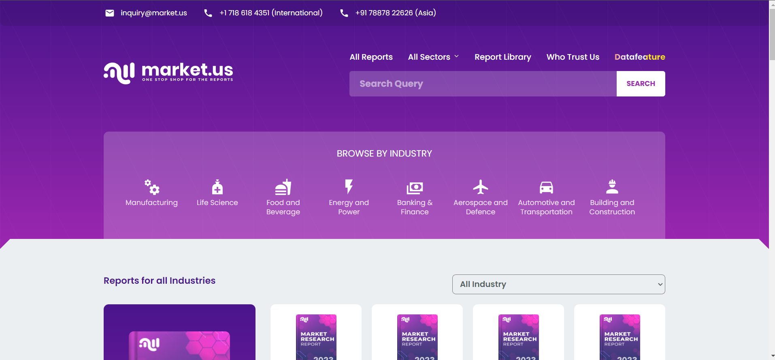Source: Prudour

Market.us includes all global reports as well as customized reports as per the client requirement

**Sectors-**

* + - Automotive
    - Chemical and Material
    - Consumer Good
    - Energy
    - Defense
    - Technology Media
    - Electronics and Semiconductor
    - Food and Beverages
    - Manufacture and Construction
    - Market Research
    - Medical Devices
    - Pharmaceutical and Healthcare

**Who Trusts Us:**

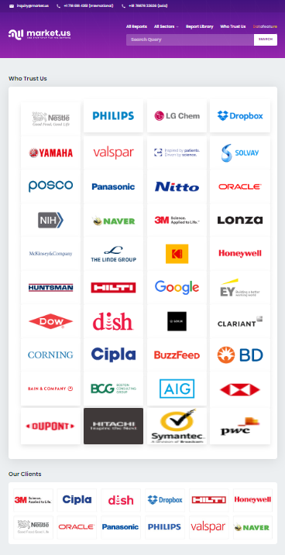

Source: Prudour

**3.3.2 Market.Biz:**

<https://market.biz/>

Market.Biz is designed to offer the most comprehensive and thorough research to all profit-making ventures, both commercial and industrial, in any industry of online business. We are proud of our ability to meet the needs of international and domestic businesses in market research. Market.Biz provides access to some of the most up-to-date and comprehensive databases available in your industry, as well as countless market reports that will provide valuable information about your business. We are sensitive to the needs of our clients and update our reports as market requirements change. Market.Biz is designed to offer the most comprehensive and thorough research to all profitmaking ventures, both commercial and industrial, in any industry of online business. We are proud of our ability to meet the needs of international and domestic businesses in market research.

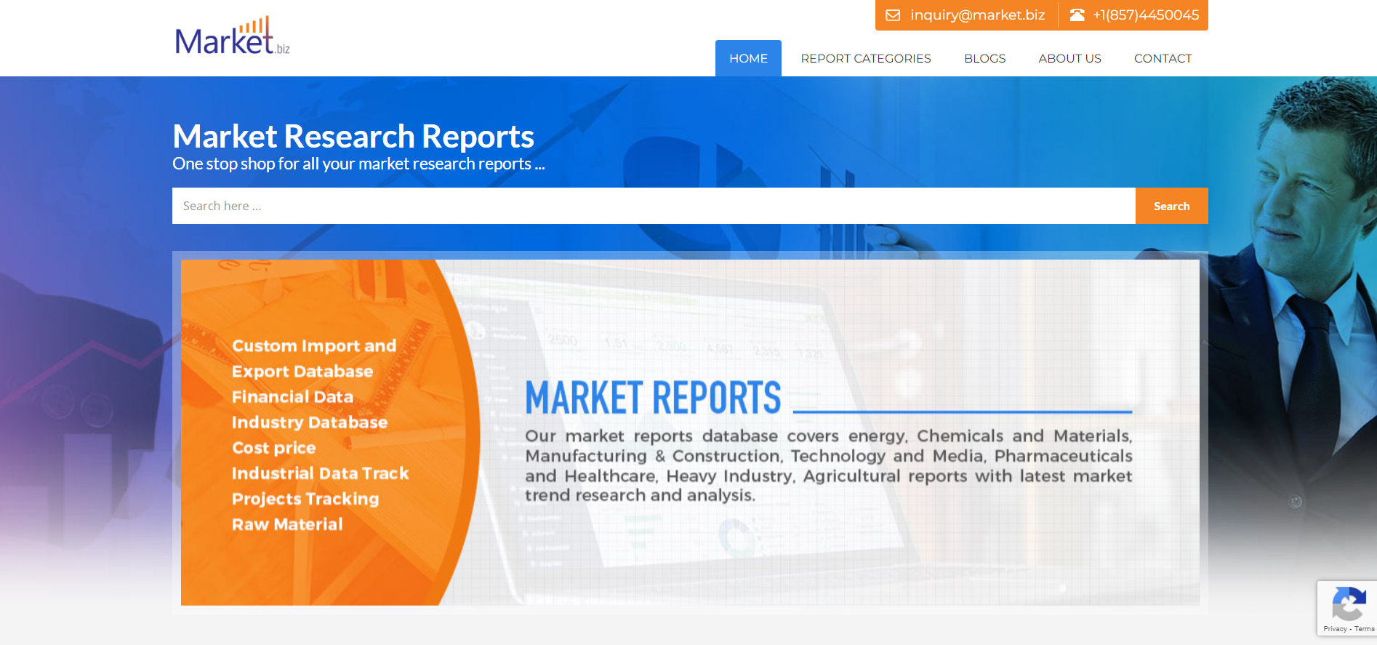Source: Prudour

Market.Biz gives you access to the most comprehensive and up-to-date databases in your industry. There are also numerous market reports that can provide valuable information about your company. We listen to our clients' needs and keep our reports updated as the market changes. The reports we provide are organized in a way that allows clients to quickly identify the most important information and access them. We are able to provide detailed analysis of competitive market sectors. We can analyze competitive markets to find new growth trends. All this information is provided in a detailed report that focuses on your market sector.

**Report Categories:**

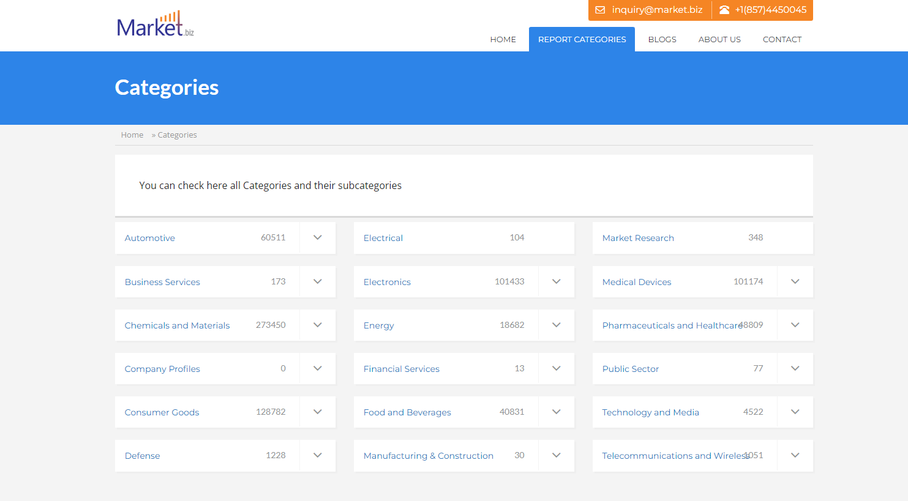Source: Prudour

**Our Clients:**



Source: Prudour

**3.3.3 MarketResearch.biz:**

<https://marketresearch.biz/our-clients/>

MarketResearch.biz provides customized research solutions through the use of its wide range of research methods, databases and resources. This is enhanced by our global experience in custom and syndicated industry projects. Our custom-made research services include market scans, country studies, market analysis, competition monitoring and supplier research satisfaction studies, , growth plans, and much more. MarketResearch.biz provides customized research solutions through the use of its wide range of research methods, databases and resources. This is enhanced by our global experience in custom and syndicated industry projects.

Source: Prudour

**Infographics:**

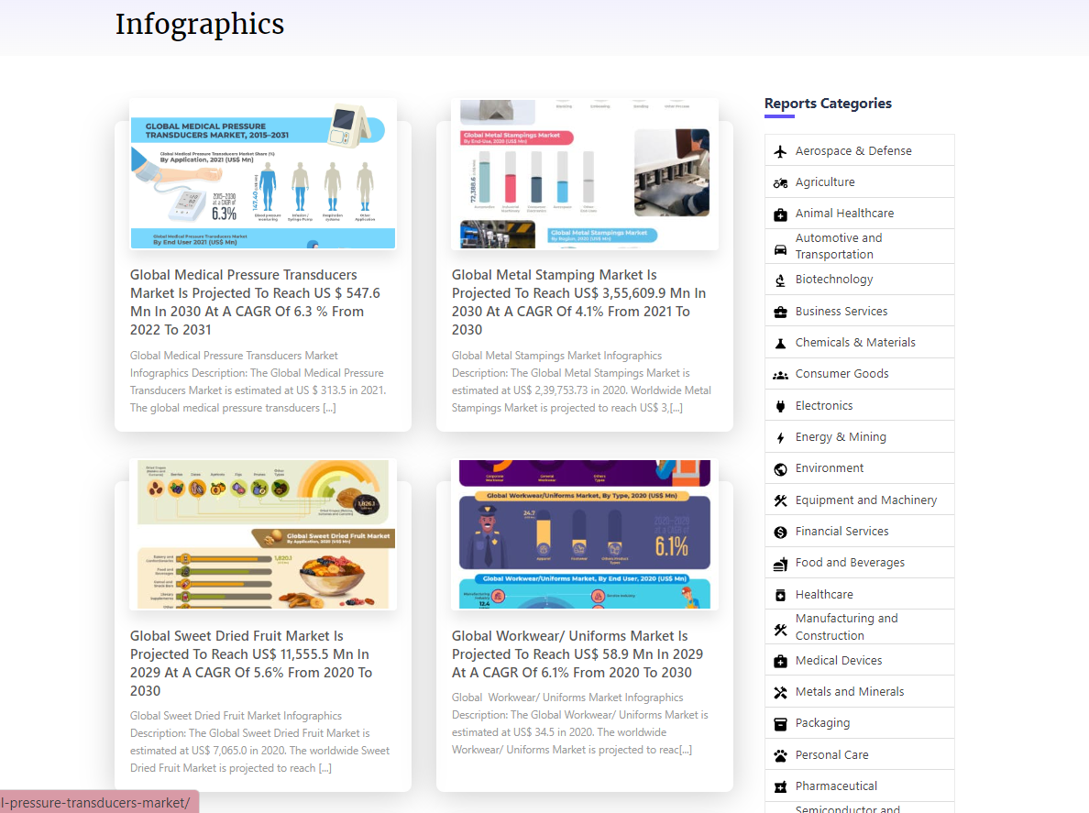Source: Prudour

Our custom-made research services include market scans, country studies, market analysis, competition monitoring and satisfaction studies, supplier research, growth plans, and much more.

**Our Clients:**

Source: Prudour

**3.3.4 Data Feature:**

<https://datafeature.com/>

Data Feature is the brainchild of a likeminded group of individuals, spread across various geographical locations, that are bound by one primary common interest – ‘The Application of Smart Business Approaches and Practices.’ We exist in a time where precise information and data translates to business power, and the exponential evolution of applied sciences and analytical capabilities, the need for superior data solutions that are both accurate and perceptive to industry-specific market landscapes, are of paramount importance! Data Feature prides itself on being a leader in providing comprehensive business analytics through innovative tools and cutting-edge data management services. Our easy-to-navigate platform will enable you to secure information (generic or niche) you wish to gain, to resolve various challenges that your business is, may or could face in the foreseeable future. We make that happen!

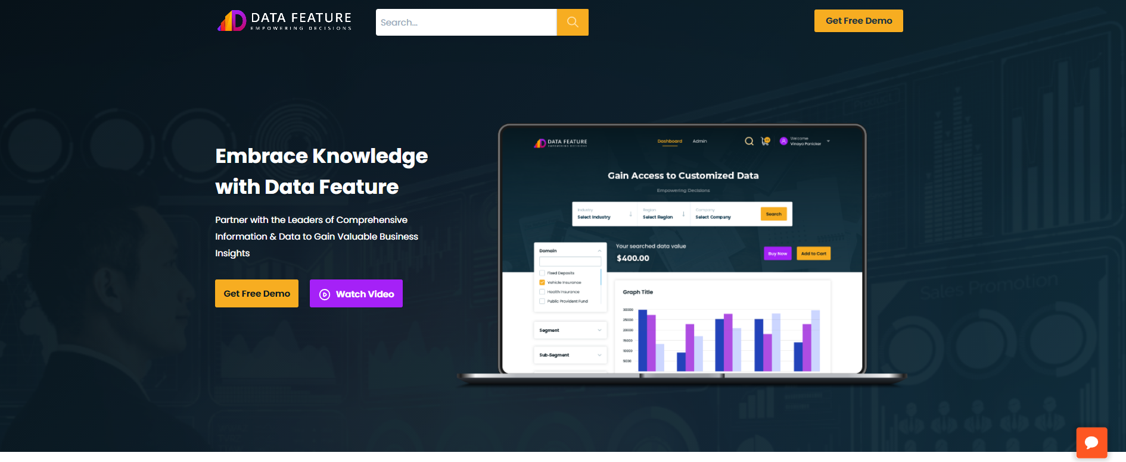Source: Prudour

Our Clients:

Source: Prudour

Chapter – IV Conceptual Framework

**4.1 Introduction**

**4.2 Drivers for the Smart Greenhouse Market**

**4.3 Restraints for the Smart Greenhouse Market**

**4.4 Opportunities for Smart Greenhouse Market**

**4.5 Trends in the Smart Greenhouse Market**

**4.6 COVID-19 Impact on the Smart Greenhouse Market**

**4.7 Dominating Region of the Smart Greenhouse Market**

**4.8 Market Overview**

**4.9 Conclusion**

**Chapter- IV**

**Conceptual Framework**

## **4.1 Introduction:**

## The smart greenhouse market has experienced remarkable growth in recent years, driven by the need for sustainable and efficient agricultural practices. Smart greenhouses are advanced facilities that integrate automation, control systems, and data-driven intelligence to create optimal growing environments for plants. By leveraging technologies such as sensors, climate control systems, artificial lighting, and irrigation management, smart greenhouses provide precise control over environmental factors crucial for plant growth. These include temperature, humidity, light, and water. The market is propelled by factors such as the increasing global population, rising demand for high-quality produce, and the need for resource optimization. Furthermore, the ability of smart greenhouses to mitigate the impact of climate change and minimize pesticide use makes them attractive for sustainable agriculture. As a result, the smart greenhouse market encompasses a diverse range of players, including greenhouse manufacturers, technology providers, and software developers, all contributing to the growth and development of this dynamic industry. With the ongoing focus on innovative and sustainable solutions for food production, the smart greenhouse market is poised to continue its upward trajectory.

## **4.2 Drivers for the Smart Greenhouse Market**

The Smart Greenhouse market is experiencing significant growth and is being driven by several key factors. Firstly, the increasing global population and the consequent rise in food demand are putting immense pressure on traditional farming methods. Smart Greenhouses offer a viable solution by maximizing crop production while minimizing resource consumption. This efficiency-driven approach appeals to farmers and investors alike, as it promises higher yields and reduced environmental impact.

Secondly, advancements in technology, particularly in the fields of automation, artificial intelligence, and IoT, have revolutionized greenhouse farming. Smart Greenhouses leverage these innovations to monitor and control various environmental factors such as temperature, humidity, lighting, and irrigation. By employing sensors, data analytics, and automated systems, farmers can optimize growing conditions, resulting in better crop quality and improved resource management.

Moreover, the growing emphasis on sustainability and eco-friendly practices is another driver in the Smart Greenhouse market. With the increasing awareness of climate change and the need to reduce carbon emissions, there is a rising demand for agricultural practices that minimize environmental harm. Smart Greenhouses offer energy-efficient solutions, incorporating renewable energy sources and advanced climate control systems to reduce reliance on traditional energy grids. Furthermore, the integration of smart farming techniques with precision agriculture is bolstering the growth of the Smart Greenhouse market. Farmers can leverage data-driven insights and predictive analytics to make informed decisions about crop management. This integration enables better pest and disease control, precise nutrient application, and optimized irrigation, leading to improved yields and reduced operational costs.

Lastly, government initiatives and subsidies supporting sustainable farming practices are propelling the adoption of Smart Greenhouses. Governments worldwide are recognizing the potential of smart farming technologies to address food security concerns, conserve natural resources, and promote economic growth in the agricultural sector. These incentives encourage farmers to invest in Smart Greenhouses and accelerate the market growth.

In conclusion, the Smart Greenhouse market is being driven by factors such as the increasing global food demand, technological advancements, sustainability requirements, the integration of precision agriculture, and government support. As the benefits of Smart Greenhouses become more apparent, farmers are embracing these innovative solutions to enhance productivity, reduce environmental impact, and ensure a sustainable future for agriculture.

## **4.3 Restraints for the Smart Greenhouse Market**

While the Smart Greenhouse market holds immense potential, there are several restraints that impact its growth and widespread adoption. One significant restraint is the high initial cost associated with setting up smart greenhouse infrastructure. The integration of advanced technologies, such as sensors, automation systems, and data analytics, requires substantial investments, which can deter smaller farmers and agricultural businesses with limited financial resources.

Additionally, the complexity of implementing and managing smart greenhouse systems can pose a challenge. Farmers may lack the necessary technical expertise to operate and maintain these sophisticated systems effectively. The integration of multiple technologies and the need for continuous monitoring and troubleshooting can result in a steep learning curve and increased operational costs. Another restraint is the reliance on stable and high-speed internet connectivity. Smart Greenhouses heavily rely on internet connectivity to transmit data from sensors, control systems, and other connected devices. However, in some remote or rural areas, access to reliable internet infrastructure may be limited or inconsistent. This can hinder real-time monitoring and control of greenhouse conditions, compromising the effectiveness of smart farming techniques.

Furthermore, concerns related to data security and privacy can act as restraints in the Smart Greenhouse market. Smart Greenhouses generate vast amounts of data, including crop information, environmental conditions, and farm operations. Protecting this sensitive data from cyber threats and ensuring privacy compliance can be a daunting task. Farmers and stakeholders may hesitate to adopt smart greenhouse solutions due to concerns about data breaches or unauthorized access.

In conclusion, the Smart Greenhouse market faces restraints such as high initial costs, complexity in implementation, and dependence on stable internet connectivity, compatibility issues, data security concerns, and regulatory challenges. Overcoming these restraints will require addressing cost barriers, providing user-friendly solutions, improving internet infrastructure, promoting standardization, strengthening data security measures, and establishing supportive policies and regulations. By addressing these challenges, the Smart Greenhouse market can unlock its full potential and contribute to sustainable and efficient agricultural practices.

## **4.4 Opportunities for Smart Greenhouse Market**

The Smart Greenhouse market is ripe with opportunities that can drive its growth and create new avenues for innovation and profitability. One significant opportunity lies in the increasing demand for locally grown and fresh produce. Smart Greenhouses enable year-round cultivation and localized food production, reducing dependence on long-distance transportation and ensuring the availability of fresh and nutritious produce. By capitalizing on the rising consumer preference for locally sourced food, Smart Greenhouse operators can tap into a growing market segment and establish a competitive advantage.

Additionally, collaborations and partnerships between technology providers and agricultural stakeholders offer opportunities for innovation and market expansion. By combining expertise from the agricultural and technology sectors, new solutions can be developed to address specific challenges faced by farmers. These collaborations can foster the development of customized smart greenhouse solutions, tailored to the unique needs of different crop types, climates, and farming practices.

In conclusion, the Smart Greenhouse market presents various opportunities for growth and innovation. Leveraging the demand for local produce, embracing vertical farming techniques, harnessing the power of data analytics and AI, integrating renewable energy sources, and fostering collaborations within the industry can unlock the full potential of Smart Greenhouses. By capitalizing on these opportunities, stakeholders can contribute to sustainable agriculture, meet the evolving consumer demands, and drive the transformation of the global food system.

## **4.5 Trends in the Smart Greenhouse Market**

The Smart Greenhouse market is witnessing several trends that are shaping the future of agricultural practices. One prominent trend is the adoption of Internet of Things (IoT) technology in greenhouse operations. IoT enables the integration of sensors, actuators, and smart devices, allowing real-time monitoring and control of various parameters such as temperature, humidity, CO2 levels, and soil moisture. This connectivity and data-driven approach empower farmers to make informed decisions, optimize resource usage, and automate processes, resulting in increased efficiency and improved crop yields.

The integration of robotics and automation is another notable trend in the Smart Greenhouse market. Robotic systems can perform tasks such as planting, harvesting, and crop maintenance with precision and efficiency. They can work tirelessly, reducing the labor-intensive nature of greenhouse operations and addressing labor shortages in the agriculture sector. Automated systems, including robotic arms, conveyor belts, and sorting machines, streamline processes and enable faster production cycles, ensuring timely delivery of fresh produce.

Moreover, data analytics and cloud-based platforms are becoming increasingly prevalent in smart greenhouse operations. These technologies allow farmers to collect and analyze data from multiple sources, including sensors, weather forecasts, and crop performance. Cloud platforms offer centralized data storage, remote access, and collaborative features, facilitating data-driven decision-making and enabling seamless integration across different greenhouse locations. This trend promotes scalability, standardization, and the sharing of best practices within the smart greenhouse community.

## **4.6 COVID-19 Impact on the Smart Greenhouse Market**

The COVID-19 pandemic has had a profound impact on various industries worldwide, and the Smart Greenhouse market is no exception. While the pandemic presented numerous challenges, it also highlighted the importance of sustainable and resilient food production systems. As a result, the Smart Greenhouse market experienced both setbacks and opportunities during these unprecedented times.

Moreover, the pandemic accelerated the digital transformation of the agriculture industry. The need for remote monitoring, control, and data-driven decision-making became crucial as travel restrictions limited physical access to greenhouse facilities. Smart Greenhouses, equipped with IoT sensors, data analytics, and cloud platforms, allowed farmers to monitor and manage greenhouse conditions remotely, ensuring the optimal growth of crops. This digital shift propelled the adoption of smart farming technologies and created new opportunities for technology providers in the market.

In conclusion, the COVID-19 pandemic had a mixed impact on the Smart Greenhouse market. Supply chain disruptions and logistical challenges posed setbacks, hindering the establishment and expansion of smart greenhouse facilities. However, the increased emphasis on food security, supply chain resilience, and automation accelerated the adoption of smart greenhouse solutions. The pandemic acted as a catalyst for the market, highlighting the importance of sustainable and technology-driven farming practices. As the world recovers and adapts to the new normal, the Smart Greenhouse market is poised to play a vital role in building resilient and sustainable food systems.

## **4.7 Dominating Region of the Smart Greenhouse Market**

Europe dominates the Smart Greenhouse market for several reasons. Firstly, Europe has a strong agricultural tradition and a deep understanding of horticulture practices. The region's expertise in greenhouse cultivation and precision agriculture has paved the way for the adoption of Smart Greenhouses. European farmers and researchers have been at the forefront of developing and implementing advanced technologies to optimize crop production and resource management.

Moreover, Europe's dense population and limited arable land availability have led to a focus on high-value and intensive agriculture. Smart Greenhouses provide a solution to maximize productivity in a limited space while minimizing environmental impact. The controlled environment and precise management of growing conditions in Smart Greenhouses allow for year-round cultivation and higher crop yields, meeting the demands of densely populated regions. Furthermore, European governments have been proactive in supporting research and development, innovation, and technology adoption in agriculture. They provide grants, subsidies, and funding opportunities to farmers and businesses investing in Smart Greenhouse systems. These incentives facilitate the adoption of advanced technologies and drive market growth.

In conclusion, Europe's dominance in the Smart Greenhouse market can be attributed to its agricultural expertise, commitment to sustainability, favorable regulatory environment, population density, government support, robust technology infrastructure, and consumer preferences. These factors have positioned Europe as a leader in adopting and promoting Smart Greenhouse technologies, driving innovation and market growth in the region.

## **4.8 Market Overview:**

In 2022, the global Smart Greenhouse market was accounted at US$ 3196.36 million. Between 2023 and 2032, this market is estimated to register the highest CAGR of 10.9%. Market players are actively working on developing modern greenhouse market. Key players like Ridder Group, Priva, Heliospectra, Signify (formerly Philips Lighting), Argus Control Systems Ltd., Logiqs B.V., Netafim, Certhon, Rough Brothers, Inc. (RBI), LumiGrow, Hoogendoorn Growth Management, GreenTech Agro LLC. The Smart Greenhouse market refers to the application of advanced technologies and automation systems in greenhouse farming to optimize crop production, resource management, and environmental sustainability. Smart Greenhouses utilize a range of technologies, including sensors, data analytics, artificial intelligence, Internet of Things (IoT) devices, and automation systems to monitor and control various environmental factors such as temperature, humidity, lighting, irrigation, and nutrient levels.

The market for Smart Greenhouses has been growing steadily due to several factors. Firstly, the increasing global population and the subsequent rise in food demand have put pressure on traditional farming methods. Smart Greenhouses offer a solution by maximizing crop yields while minimizing resource consumption, leading to more efficient and sustainable agriculture.

**Segments Covered:**

**Type**

* Hydroponic
* Non-Hydroponic
* By Covering Material Type
* [Polyethylene](https://marketresearch.biz/report/polyethylene-market/)
* Polycarbonate
* Other Types

**End-User**

* Commercial Growers
* Research & Educational Institutes
* Retail Gardens
* Others

**Components**

* HVAC Systems
* LED Grow Lights
* Irrigation System
* Valves & Pumps
* Sensor & System
* Others

**4.9 Conclusion:**

These are the segments covered while dividing the Smart Greenhouse in different parts and based on these segments we are forecasting the market size in 2032. The market and segments growth is also forecasted with the help of these segments. With the help of the past data and base year which is 2021 and CAGR (Compound Annual Growth Rate) we are forecasting and analyzing the markets growth. The study is vast and it will help global players operating in Smart Greenhouse business. The company provides us the required Microsoft Tools and with the help of these tools we are forecasting the market and their segments growth.

Chapter – V Data Analysis and Interpretation

**5.1 Introduction**

**5.2 Data Analysis and Interpretation**

**Chapter- V**

**Data Analysis and Interpretation**

## **5.1 Introduction:**

Data analysis is a course of reviewing, changing, cleansing and displaying information fully intent on finding valuable data, informing conclusions, and supporting choice-making. Data analysis has numerous features and approaches enveloping various methods under various names and is utilized in multiple business, science, and sociology domains. In the present business world, data analysis assumes a part in pursuing choices more logically and assisting organizations with working all the more successfully.

The data analysis is done after collecting the data through the websites, press releases, and reports. Before data analysis, edit tabulations of the data are done in excel; after a code sheet is formed, these specific codes are given to the data, making it easy to analyze; our data is qualitative.

## **5.2 Data Analysis and Interpretation:**

**5.2.1 Market Growth of Global Smart Greenhouse Market from 2022 to 2032:**

Table 1 Market Growth of Global Smart Greenhouse Market From 2022 to 2032:

|  |  |  |
| --- | --- | --- |
| **Years** | **Details** | **Values (2022)** |
| 2022 | Market Size | 3196 Million |
| CAGR | 10.9% |
| **2032** | **Market Size** | **8764 Million** |
| **(F) CAGR** | **10.9%** |

Source: Secondary Data

Fig. 1 Market Growth of Global Smart Greenhouse Market from 2022 to 2032:

Source: Secondary Data

**Interpretation:**

We can clearly see the market growth of Global Smart Greenhouse Market with compound annual growth rate (CAGR) of 10.9%. The market will grow from 3196 million in 2022 to 8764 million in 2032 with and the CAGR is also good for the market so it will be a good sign for the Smart Greenhouse manufacturing firms.

**5.2.2** **Global Smart Greenhouse Market Share Comparison by Type (2016-2032)**

Table 2 Global Smart Greenhouse Market Share Comparison by Type (2016-2032)

|  |  |  |
| --- | --- | --- |
| **Sr. No.** | **Types** | **Percentage of Share Held** |
| 1 | Hydroponic | 28% |
| 2 | Non-Hydroponic | 22% |
| 3 | By Covering Material Type | 15% |
| 4 | [Polyethylene](https://marketresearch.biz/report/polyethylene-market/) | 16% |
| 5 | Polycarbonate | 12% |
| 6 | Other Types | 7% |

Source: Secondary Data

Fig. 2 Global Smart Greenhouse Market Share Comparison by Type (2016-2032)

Source: Secondary Data

**Interpretation:**

The figure shows the growth rate of different types which includes hydroponic, non-hydroponic, by covering material type, polyethylene, polycarbonate, and other types. Based on past and present data the Hydroponic is the dominator type class in the Smart Greenhouse Market.

**5.2.3 Global Smart Greenhouse Market Share Comparison by End-User (2016-2032)**

Table 3 Global Smart Greenhouse Market Share Comparison by End-User (2016-2032)

|  |  |  |
| --- | --- | --- |
| **Sr. No.** | **End-Users** | **Percentage of Share Held** |
| 1 | Commercial Growers | 37% |
| 2 | Research & Educational Institutes | 27% |
| 3 | Retail Gardens | 20% |
| 4 | Others | 16% |

Source: Secondary Data

Fig. 3 Global Smart Greenhouse Market Share Comparison by End-User (2016-2032)



Source: Secondary Data

**Interpretation:**

The above figure shows the percentage of revenue generated from the end-user segment which includes the Commercial Growers, Research & Educational Institutes, Retail Gardens, and Others. The Research & Educational Institutes segment is dominant in the Global Smart Greenhouse Market. Research & Educational Institutes market share is 37%.

**5.2.4. Global Smart Greenhouse Market Share Comparison by Component (2016-2032)**

Table 4 Global Smart Greenhouse Market Share Comparison by Component (2016-2032)

|  |  |  |
| --- | --- | --- |
| **Sr. No.** | **Component** | **Percentage of Share Held** |
| 1 | LED Grow Lights | 28% |
| 2 | HVAC Systems | 22% |
| 3 | Irrigation System | 17% |
| 4 | Valves & Pumps | 17% |
| 5 | Sensor & System | 11% |
| 6 | Others | 5% |

Source: Secondary Data

Fig. 4 Global Smart Greenhouse Market Share Comparison by Component (2016-2032)



Source: Secondary Data

**Interpretation:**

The figure shows component wise percentage of revenue generated by various segments like HVAC Systems, LED Grow Lights, Irrigation System, Valves & Pumps, Sensor & System, and Others. The LED Grow Lights is dominant in the Global Smart Greenhouse Market with 28%.

**5.2.5 Global Smart Greenhouse Market Share Comparison by Growth Opportunities (2022)**

Table 5 Global Smart Greenhouse Market Share Comparison by Growth Opportunities (2022)

|  |  |  |
| --- | --- | --- |
| **Sr. No.** | **Types** | **Percentage of Share Held** |
| 1 | Innovation and Profitability | 42% |
| 2 | Demand for Fresh Produce | 18% |
| 3 | Reduce Long-Distance Transportation | 15.0% |
| 4 | New Solutions | 11.0% |
| 5 | Other Opportunities | 6.9% |

Source: Secondary Data

Fig. 5 Global Smart Greenhouse Market Share Comparison by Growth Opportunities (2022)



Source: Secondary Data

**Interpretation:**

The increasing demand for locally grown and fresh produce and Smart Greenhouses enable year-round cultivation and localized food production, reducing dependence on long-distance transportation and ensuring the availability of fresh and nutritious produce. By capitalizing on the rising consumer preference for locally sourced food, Smart Greenhouse operators can tap into a growing market segment and establish a competitive advantage.

**5.2.6 Global Smart Greenhouse Pre Covid-19 Market Share Comparison (2022)**

Table 6 Global Smart Greenhouse Pre Covid-19 Market Share Comparison (2022)

|  |  |  |
| --- | --- | --- |
| **Years** | **Details** | **Values (2022)** |
| 2017 | Market Size | 1376 million |
| CAGR | 8% |
| **2027** | **Market Size** | **2914 million** |
| **(F) CAGR** | **8%** |

Source: Secondary Data

Fig. 6 Global Smart Greenhouse Pre Covid-19 Market Share Comparison (2022)



Source: Secondary Data

**Interpretation:**

The market was projected to grow at a healthy pace, with estimates suggesting a value of over $1376 million by 2017 and a compound annual growth rate (CAGR) of around 8% during the forecast period.

**5.2.7 Global Smart Greenhouse Post Covid-19 Market Share Comparison (2022)**

Table 7 Global Smart Greenhouse Post Covid-19 Market Share Comparison (2022)

|  |  |  |
| --- | --- | --- |
| **Years** | **Details** | **Values (2022)** |
| 2022 | Market Size | 3196 Million |
| CAGR | 10.9% |
| **2032** | **Market Size** | **8764 Million** |
| **(F) CAGR** | **10.9%** |

Source: Secondary Data

Fig. 7 Global Smart Greenhouse Post Covid-19 Market Share Comparison (2022)



Source: Secondary Data

**Interpretation:**

The pandemic highlighted vulnerabilities in global food supply chains, prompting a renewed focus on food security and local production. Smart greenhouses can play a crucial role in ensuring a consistent and reliable food supply by enabling year-round cultivation of crops in controlled environments. The demand has increased.

**5.2.5 Global Smart Greenhouse Market Share Comparison by Region (2016-2032)**

Table 5 Global Smart Greenhouse Market Share Comparison by Region (2016-2032)

|  |  |  |
| --- | --- | --- |
| **Sr. No.** | **Regions** | **Percentage of Share Held** |
| 1 | North America | 18% |
| 2 | Latin America | 11% |
| 3 | Europe | 31% |
| 5 | APAC | 27% |
| 5 | MEA | 10% |

Source: Secondary Data

Fig. 5 Global Smart Greenhouse Market Share Comparison by Region (2016-2032)



Source: Secondary Data

**Interpretation:**

The above figure shows that the regional market share of Smart Greenhouse. The Europe is dominant among other regions which holds 31% of market share of Smart Greenhouse. Followed by Latin America and APAC. Asia-Pacific is expected to grow faster and it is expected to have high CAGR among these regions. So, it creates opportunities for APAC Smart Greenhouse manufacturers in the market.

## **5.3 Conclusion:**

In conclusion, the global Smart Greenhouse Market has witnessed significant growth and advancements in recent years. The market has been driven by various factors such as the increasing global population and the consequent rise in food demand are putting immense pressure on traditional farming methods. Smart Greenhouses offer a viable solution by maximizing crop production while minimizing resource consumption. This efficiency-driven approach appeals to farmers and investors alike, as it promises higher yields and reduced environmental impact.

Moreover, the pandemic accelerated the digital transformation of the agriculture industry. The need for remote monitoring, control, and data-driven decision-making became crucial as travel restrictions limited physical access to greenhouse facilities. Smart Greenhouses, equipped with IoT sensors, data analytics, and cloud platforms, allowed farmers to monitor and manage greenhouse conditions remotely, ensuring the optimal growth of crops. This digital shift propelled the adoption of smart farming technologies and created new opportunities for technology providers in the market

Chapter – VI Findings, Conclusion, and Suggestions

**6.1 Introduction**

**6.2 Findings**

**6.3 Suggestions**

**6.4 Conclusion**

**Chapter- VI**

**Findings, Suggestions, and Conclusion**

## **6.1 Introduction:**

After analyzing the data in excel and MS Office, interpreting the data, and mentioning the findings, we get solutions to our research problem. We give suggestions to the organizations operating in Smart Greenhouse to point out where is a need for improvement, as well as it should help to achieve the organizational objective, satisfy the customer’s needs and demands, and assist in designing the products per the customer’s requirements. It helps to formulate a marketing strategy to get maximum customers.

## **6.2 Findings**

* From the above survey I found that the market for Smart Greenhouse is growing rapidly. (Table No. 1)
* From the above survey I found that the Hydroponic is the most used type for the smart greenhouses. (Table No. 2)
* Research & Educational Institutes is most use smart greenhouse in today’s market. (Table No. 3)
* From the above study I found that the LED grow lights have dominate as nearly 28% of revenue is generated from component segment. (Table No. 4)
* The study conclude that the rising innovation and profitability creates opportunities for the firms. (Table No. 5)
* From above research we found that the pre covid-19 compound annual growth rate is low as compared to post covid. (Table No. 6)
* The study also concludes that the after covid-19 there is increase in growth rates because of covid-19 pandemic. (Table No. 7)
* The Europe generated the highest revenue share in global smart greenhouse market followed by North America and APAC. (Table No. 8)

## **6.3 Suggestions:**

The suggestions are for the Smart Greenhouse manufacturers all around the world because this study will help all the organizations with understanding the growth and advancement of this market and it will help them to create and strategies which can give them a competitive advantage over their competitors. This study is also helpful for the new commers in this field.

**Research and Development:** Continued investment in research and development is essential for driving innovation and advancing smart greenhouse technologies. Encourage collaborations between technology companies, agricultural researchers, and greenhouse operators to develop new solutions, optimize existing technologies, and address specific challenges in crop production.

**Integration of IoT and Data Analytics:** Emphasize the integration of Internet of Things (IoT) devices and data analytics in smart greenhouse systems. This enables real-time monitoring, data collection, and analysis to optimize resource utilization, automate processes, and provide actionable insights for better decision-making.

**Customization and Scalability:** Focus on developing smart greenhouse solutions that are flexible, customizable, and scalable. Every greenhouse has unique requirements, and providing modular systems that can adapt to different sizes, crops, and environmental conditions will enhance their adoption and market potential.

**Education and Training:** Offer training programs and resources to educate greenhouse operators, farmers, and technicians on the benefits and implementation of smart greenhouse technologies. This will ensure a skilled workforce capable of effectively utilizing and managing these advanced systems.

**Government Support and Incentives:** Encourage government support and incentives for the adoption of smart greenhouse technologies. Financial incentives, tax benefits, and research grants can incentivize greenhouse operators to invest in smart systems, promoting sustainable and efficient agriculture practices.

**Collaboration and Knowledge Sharing:** Facilitate collaboration and knowledge sharing among stakeholders in the smart greenhouse industry. This can be done through industry conferences, workshops, and online platforms where professionals can exchange ideas, share best practices, and stay updated on the latest trends and advancements.

**Sustainability and Environmental Considerations:** Emphasize the sustainability aspects of smart greenhouse technologies, such as energy efficiency, water conservation, and reduced chemical usage. Highlight the environmental benefits of smart greenhouses, aligning with the growing demand for sustainable and eco-friendly agricultural practices.

**Market Awareness and Outreach**: Increase awareness of the benefits and potential of smart greenhouses through targeted marketing and outreach efforts. Showcase successful case studies, demonstrate cost savings and yield improvements, and highlight the positive environmental impact of adopting smart greenhouse technologies.

## **6.4 Conclusion:**

In conclusion, the findings of the survey indicate a rapid growth in the market for smart greenhouses. The dominance of hydroponics as the most used type of smart greenhouse highlights the increasing adoption of advanced cultivation techniques. Research and educational institutes are leading the way in implementing smart greenhouse technologies, showcasing the importance of knowledge exchange and collaboration in driving innovation. LED grow lights have emerged as a dominant component in the smart greenhouse market, generating a significant portion of the revenue. This reflects the energy efficiency, customizable spectrum, and long lifespan advantages of LED technology. The study suggests that the rising innovation and profitability in the smart greenhouse market present opportunities for firms to enhance their competitive position.

Furthermore, the research highlights the impact of the COVID-19 pandemic on the smart greenhouse market. Post-pandemic growth rates have shown an increase compared to pre-COVID-19 rates, likely due to the heightened focus on food security, sustainability, and local production. The study also reveals that Europe has generated the highest revenue share in the global smart greenhouse market, followed by North America and the Asia-Pacific region. To capitalize on the growth potential of the smart greenhouse market, it is recommended that manufacturers focus on research and development, integrate IoT and data analytics, provide customization and scalability options, offer education and training programs, seek government support and incentives, foster collaboration and knowledge sharing, prioritize sustainability and environmental considerations, and increase market awareness and outreach.

Overall, the findings emphasize the importance of technological advancements, market awareness, and collaboration to drive the smart greenhouse industry forward, contributing to sustainable agriculture, improved food production, and environmental stewardship.

REFERENCES / BIBLIOGRAPHY

**BIBLIOGRAPHY**

# References

Anne Fortin M.D., P. M. (2007). Impact of infertility drugs after treatment of borderline ovarian tumors. *ELESVIER*, Vol. 87 (591-596).

Battista, P. (2020). Smart Greenhouse Environmental Control and Management Systems: A Review. *Computers and Electronics in Agriculture.*

Chia, P. L. (2020). A Review on Smart Greenhouse Technologies: Challenges and Opportunities. *Journal of Advanced Research in Dynamical and Control Systems*, 532-553.

Gómez-Castro, F. (2021). A Review of Wireless Sensor Networks for Smart Greenhouse Applications.". *Sensors*.

Körpeoğlu, K. (2021). Smart Greenhouses: A Systematic Literature Review. *Computers and Electronics in Agriculture.*, 302-318.

Li, T. (2018). Smart Greenhouse: A Concept of Intelligent Greenhouse for Sustainable Agriculture. *International Journal of Agricultural and Biological Engineering*.

Ntinas, G. e. (2020). Smart Greenhouses: A Comprehensive Review. *Applied Sciences*, 15-24.

Pandey, A. e. (2019). Smart Greenhouse Technology: A Review. *International Journal of Research and Analytical Reviews*, 230-245.

Rad, M. H. (2021). Artificial Intelligence Applications in Smart Greenhouses: A Review. *Computers and Electronics in Agriculture.*

Ravanfar, S. A. (2020). A Comprehensive Review on Intelligent Greenhouse Systems: Components, Systems Architecture, and Future Perspectives. *Computers and Electronics in Agriculture.*

Seyedzadeh, S. (2018). Smart Greenhouses: An Overview. *International Journal of Agricultural and Biological Engineering.*, 435-443.

Tsirogiannis, I. L. (2020). A Review on the Use of Robotics in Greenhouse Crop Management. *Robotics*.

Ustaoglu, B. (2021). A Comprehensive Review of Indoor Farming Practices Using Artificial Lighting Systems. . *Agronomy*.

Zhang, C. (2018). Smart Greenhouse Control Systems: A Review. *IFAC-PapersOnLine*.